Judah

4th born to Jacob & Leah (Genesis 29:35)

After selling their brother Joseph into slavery, Judah travels “down from his brethren” (Genesis 38:1) from the “vale of Hebron” (Genesis 37:14) to Adullam which is ~10.5 miles to the north west.

Hebron sits at an elevation of ~3,000 feet above sea level and Adullam (Tel Adullam) is at ~1,440 feet above sea level (difference in elevation of ~1,500 feet).

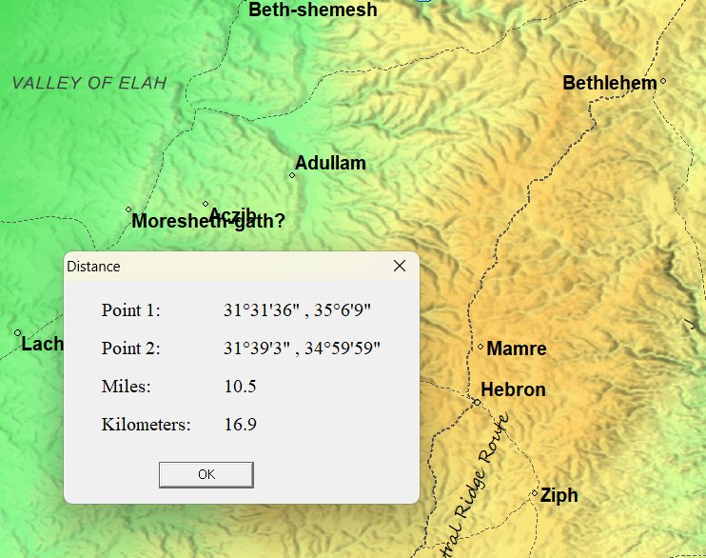
Genesis 38

Judah marries the daughter of Shuah the Canaanite. She bears to him 3 sons: Er, Onan, and Shelah. The wife is at Chezib (Aczib) when Shelah is born (which is ~ 3 miles southwest of Adullam) (Genesis 38:5).

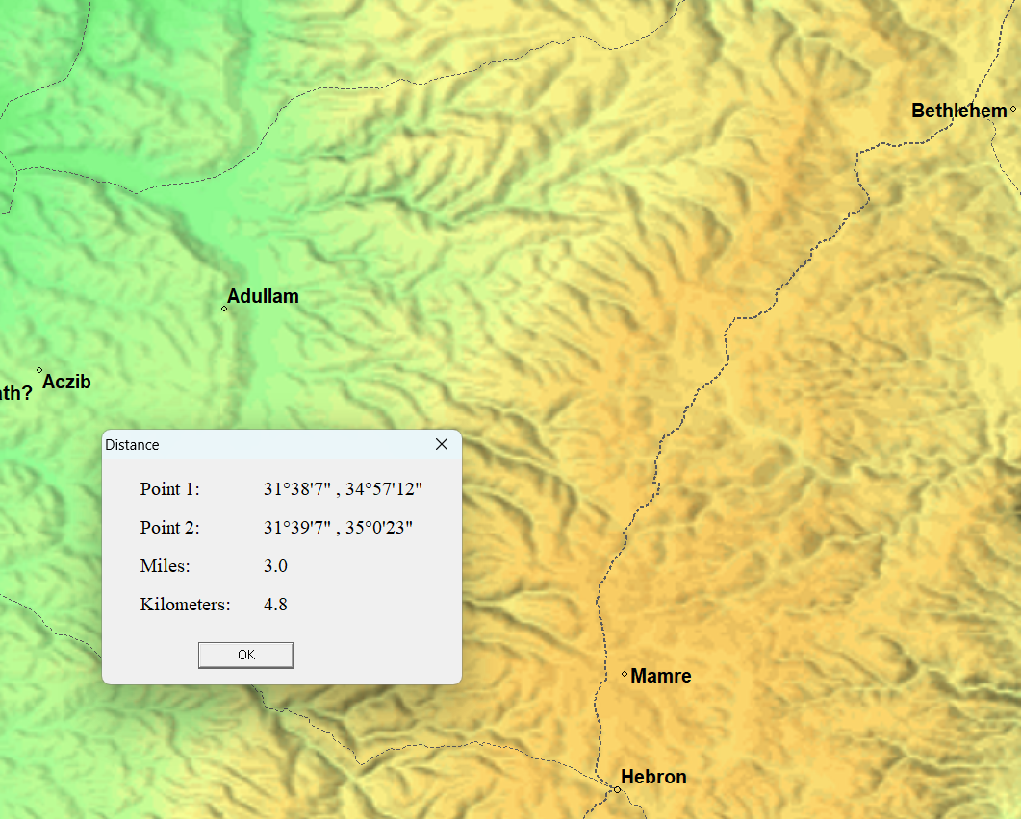

Er and Onan are slain for their wickedness and displeasing the LORD. Judah sends Tamar back to her father’s house to wait for Shelah to be of age to marry.

Some time later the wife of Judah the daughter of Shuah dies. Judah heads north ~26 miles to Timnath to sheer his sheep and Tamar seeing that Shelah was grown and she was not given to her to wife dresses as a harlot along the way. Judah and Tamar fornicate and about 3 months later it is found out that she is pregnant with twins: Pharez & Zarah.

Genesis 43

Israel sends his son a second time to Egypt and Judah

